**Experiment-8**

**A.1 Aim:** To develop the Implementation diagram of the selected project **.**

**A.2 Prerequisite:**

Coded modules, Tested modules, Database connectivity

**A.3 Outcome:**

Deployment diagram of the selected project

**A.4 Theory:**

A deployment diagram describes the organization of the physical components in a system.

1. **Nodes**

A *node* is a resource that is available during execution time. Traditionally, nodes refer to computers on a network, but in the UML a node may be a computer, printer, server, Internet, or any other kind of resource available to components. For example, the project management system may be deployed on the following nodes:

*A desktop client*

On which the user interface component executes

*A printer*

Which the project management system uses to print reports

*A business-processing server*

On which the business-processing component executes

*A database server*

On which the data component executes and where project-related information is stored.

Nodes follow the type-instance dichotomy and applied to classes and objects. You can use the UML to talk about classes of nodes, as well as specific nodes of a class. When speaking of a class of nodes, it's customary to use the terms node or *node class*. Thus, while you might think of a node as a specific thing, in the UML, a node really represents a class of nodes. When speaking of a specific component of a class, use the term *node instance*.

A node is available during execution time and is a resource on which components may execute. In the UML, a node is shown as a three-dimensional rectangle labelled with the node's name.

Figure 3 shows various nodes associated with the project management system, including a desktop client, business-processing server, database server, and printer node.

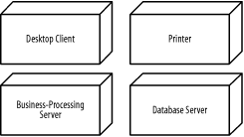

Figure 3- Nodes used by the project management system

A node instance is a specific node. For example, specific nodes used by the project management system include:

*A desktop client node instance*

Used by Jonathan to access the project management system

*A desktop client node instance*

Used by Andy to access the project management system

*A group business-processing server node instance*

Used by a group of users to manage projects

*An enterprise business-processing server node instance*

Used by a complete organization to manage projects

A node instance is shown similarly to a node class but labelled with the node instance name followed by a colon followed by the node class name, all fully underlined. Both names are optional, and the colon is present only if the node class name is specified.

Figure 4 shows various node instances of the node classes in Figure 3, including two desktop client node instances, named Jonathan's Computer and Andy's Computer, two business-processing node instances, named Group Server and Enterprise Server, a printer node instance, named Group Printer, and a database server node instance.

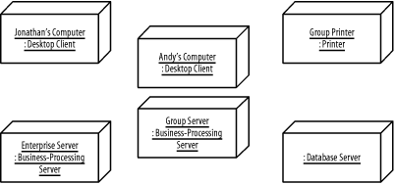

Figure 4- Node instances

1. **Dependencies**

Figure 1 shows components associated with the project management system, and Figure 3 shows nodes associated with the project management system, but how are components related to undifferentiated and differentiated classes, packages, subsystems, and to other components and nodes? Specialized types of dependencies called reside, use, and deploy dependencies address these questions. The next few sections discuss these specialized types of dependencies.

**3.1 Reside Dependencies**

A *reside* dependency from a component to any UML element indicates that the component is a client of the element, which is itself considered a supplier, and that the element resides in the component. The element may be an undifferentiated or differentiated class, package, or subsystem. An element may reside in any number of components, and a component may have any number of elements that reside in it.

A reside dependency is shown as a dashed arrow from a client component to a supplier element marked with the *reside* keyword.

Figure 5 shows that the User Interface and Utility packages reside in the User Interface component. Because the User Interface package depends on the Utility package, the User Interface and Utility packages must reside in the same component; otherwise, the User Interface package would not be able to use the Utility package.

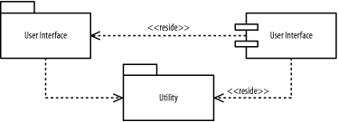

Figure 5. Reside dependencies for packages

Figure 6 shows that the Business Processing subsystem and Utility package reside in the Business Processing component. Because the Business Processing subsystem provides the IBusiness Processing interface, the Business Processing component also provides the interface. Again, because the Business Processing subsystem depends on the Utility package, the Business Processing subsystem and Utility package must reside in the same component; otherwise, the Business Processing subsystem would not be able to use the Utility package. Remember, it's perfectly fine for an element to reside in more than one component. For example, the Utility package resides in both the User Interface and Business Processing components, and, as you will soon see, in the Data component.

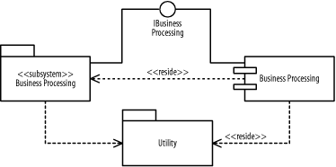

Figure 6. Reside dependencies for subsystems

Alternatively, an element that resides inside a component may be shown nested inside the component. Figure 7 shows that the Data subsystem and Utility package reside in the Data component. The Data subsystem is drawn inside the Data component, while the reside dependency to Utility is still drawn in the same manner as in Figures Figure 5 and Figure 6.

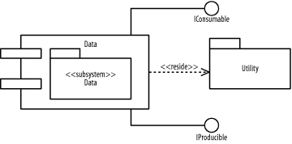

Figure 7. Reside dependencies using nesting

Notice that the Utility package resides in all the components in Figures Figure 5, Figure 6, and Figure 7, because each component described in those figures has a package that uses the Utility package.

**3.2 Use Dependencies**

A *use*dependency from a client component to a supplier component indicates that the client component uses or depends on the supplier component. A use dependency from a client component to a supplier component's interface indicates that the client component uses or depends on the interface provided by the supplier component. A use dependency is shown as a dashed arrow from a client component to a supplier component or a supplier component's interface. The dependency may be marked with the use keyword; however, the keyword is often omitted because this is the default, and the meaning is evident from how the dependency is used.

Figure 8 shows how the various components of the project management system are related:

The User Interface component-

Uses the Security component and the IBusiness Processing interface provided by the Business Processing component

The Business Processing component-

Uses the Security component and the IProducible and IConsumable interfaces provided by the Data component

The Data component-

Uses the Security component

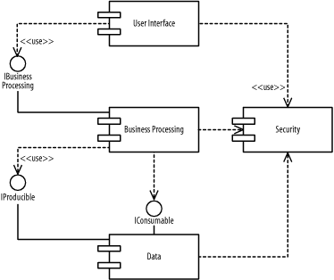

Figure 8- Use dependencies

**3.3 Deploy Dependencies**

A *deploy*dependency from a client component to a supplier node indicates that the client component is deployed on the supplier node.

A deploy dependency is shown as a dashed arrow from a client component to a supplier node marked with the *deploy* keyword.

Figure 9 shows that the User Interface component is deployed on the Desktop Client node.

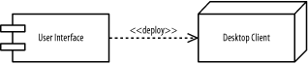

Figure 9- Deploy dependencies

Figure 10 shows that the *Business Processing* component is deployed on the *Business-Processing Server*node.

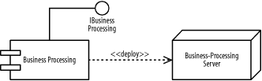

Figure 10- Deploy dependencies for a subsystem

Alternatively, a component that is deployed on a node may be shown nested inside the node. Figure 11 shows that the Data component is deployed on the *Database Server* node.

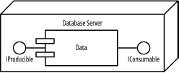

Figure 11- Deploy dependencies using nesting

**PART B**

**Experiment-11**

(PART B: TO BE COMPLETED BY STUDENTS)

(Students must submit the soft copy as per following segments within two hours of the practical. The soft copy must be uploaded on the Blackboard or emailed to the concerned lab in charge faculties at the end of the practical in case the there is no Black board access available)

|  |  |
| --- | --- |
| Roll No: C101 | Name: Samkeet Shah |
| Class: C | Batch: B3 |
| Date of experiment: | Date/Time of Submission: |
| Grade: |  |

B.1 Deployment Diagram

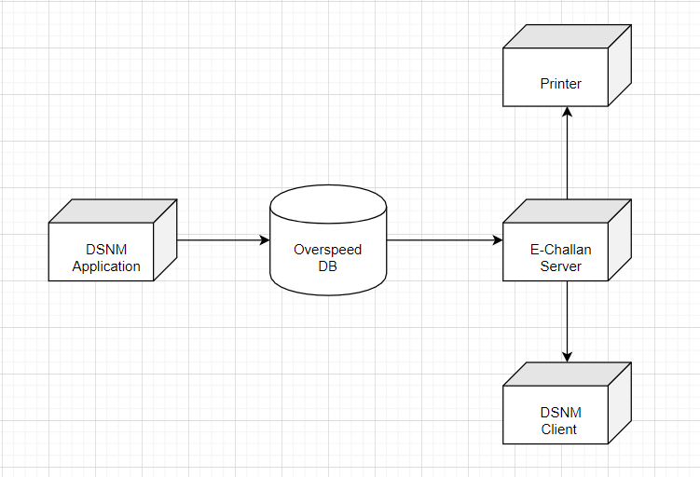

B.2 Conclusions

B.3 Question of Curiosity

*1.* What are the standard notations used for component diagram and deployment diagram.

Sol. **Deployment diagram symbols and notation**

### Nodes

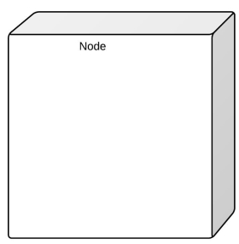

There are two types of nodes in a deployment diagram: device nodes and execution environment nodes. Device nodes are computing resources with processing capabilities and the ability to execute programs. Some examples of device nodes include PCs, laptops, and mobile phones.

An execution environment node, or EEN, is any computer system that resides within a device node. It could be an operating system, a JVM, or another servlet container.

### Database

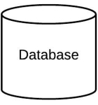

Databases represent any data stored by the deployed system. In some instances, you'll see a database represented as just another node, but sometimes you will see this shape as a database.

### Other shapes

* Communication path: A straight line that represents communication between two device nodes.
* Artifacts: A box with the header "<<artifact>>" and then the name of the file.
* Package: A file-shaped box that groups together all the device nodes to encapsulate the entire deployment.
* Component: An entity required to execute a stereotype function.

**Component diagram symbols and notation**

Component diagrams range from simple and high level to detailed and complex. Either way, you'll want to familiarize yourself with the appropriate UML symbols. The following are shape types that you will commonly encounter when reading and building component diagrams:

